**Introduction:**

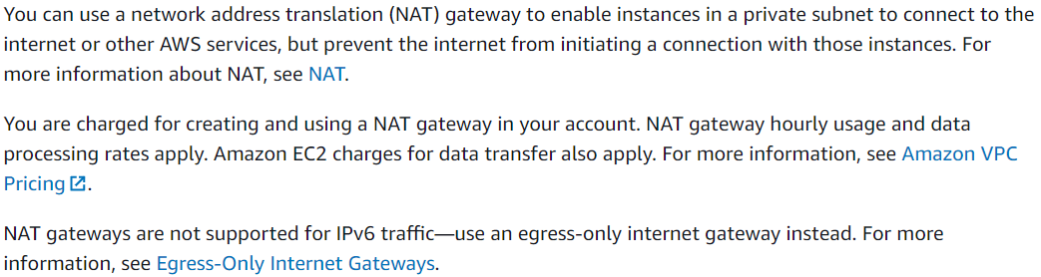

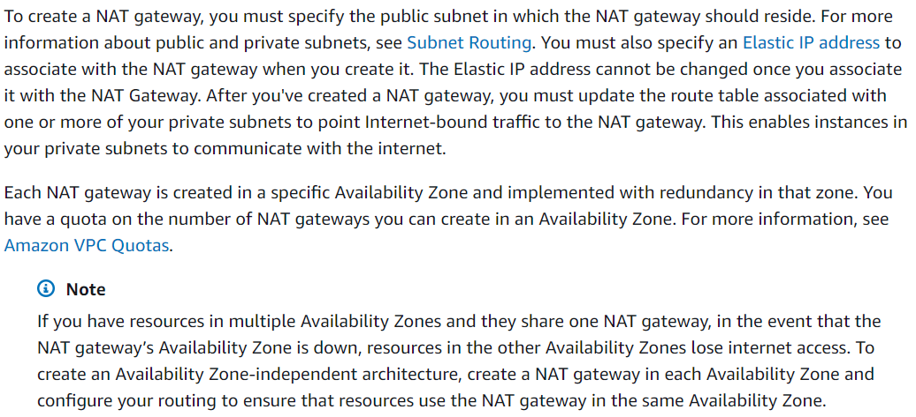

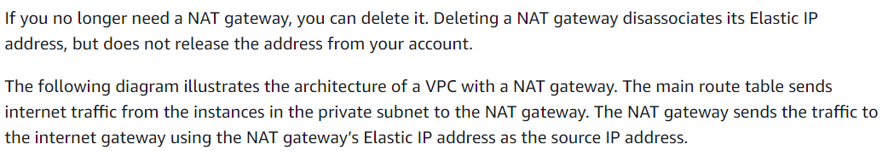

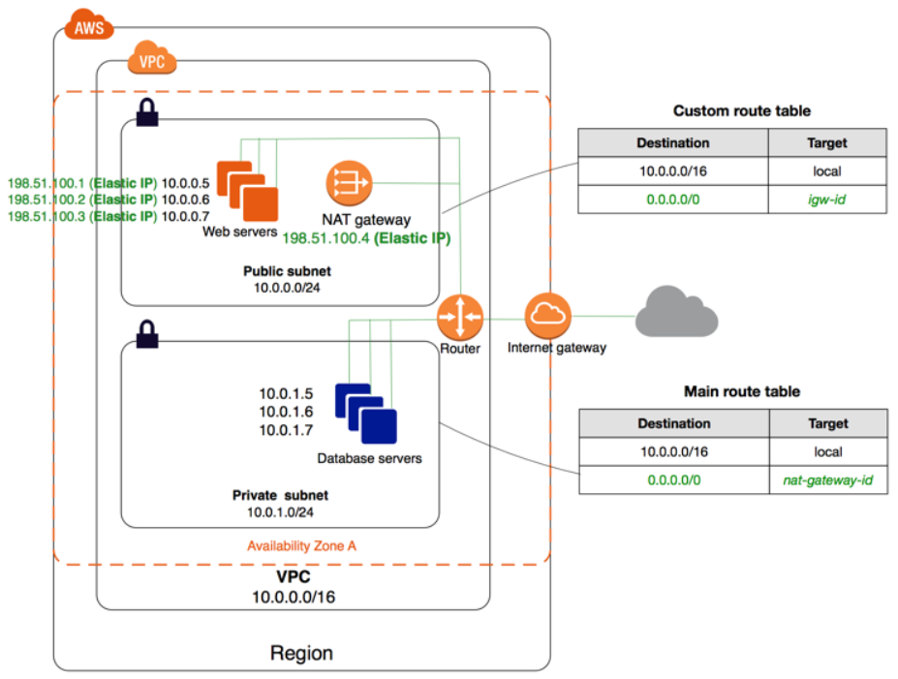

**Rules and limitations:**

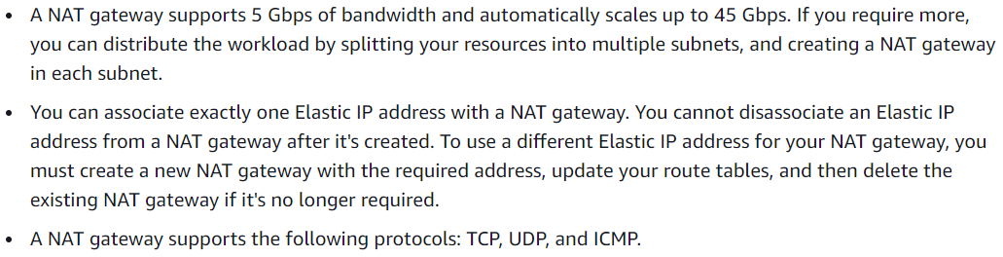

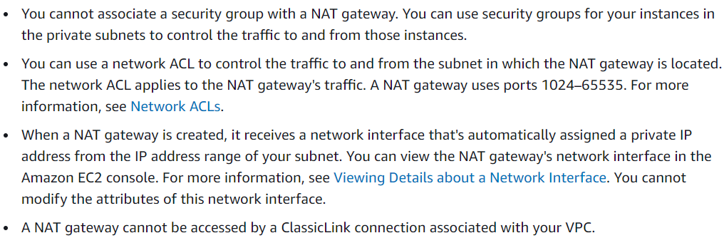

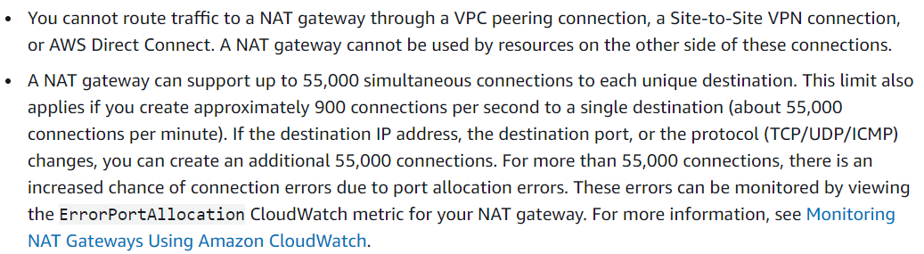

**Difference between NAT instance & gateway:**

NAT is used when we want to enable internet access to the private servers. There are two ways to do that. NAT instance & NAT gateway

NAT instance is nothing but an another ec2 instance which is used for giving internet connection to the private server. This is how it been done earlier

But then later NAT gateway came. So, that we no need to worry about NAT instance going down

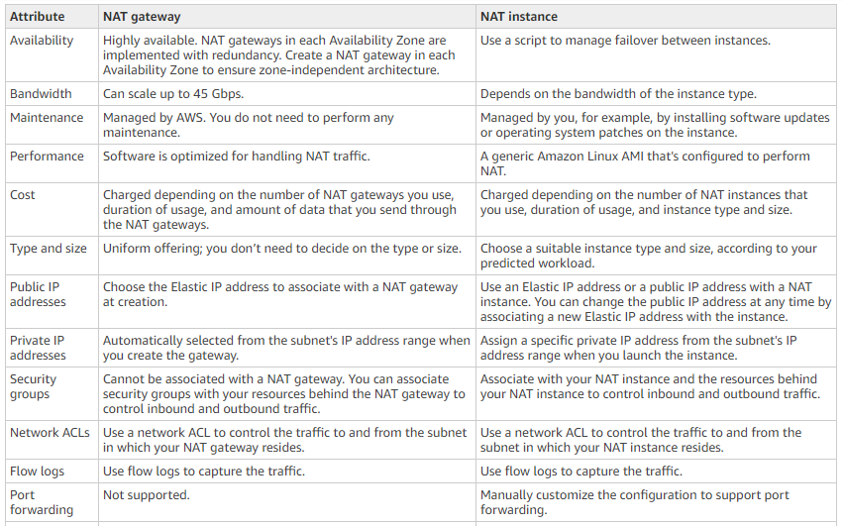

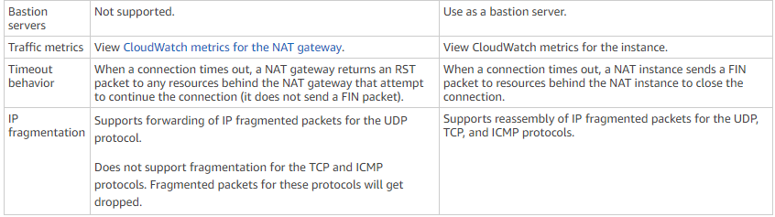

We don’t need to worry about NAT gateway goes down

But in case the availability zone where the NAT gateway is configured goes down, it may be a problem

So, it is recommended to create separate NAT gateway for every availability zone

**Creating and mapping NAT gateway:**

* If we want our DB server also access internet. We need NAT gateways for that
* If we want to enable internet access for the instance in private network, then we need NAT gateway for that
* We have to create it in public subnet. Then only it can help to access the internet

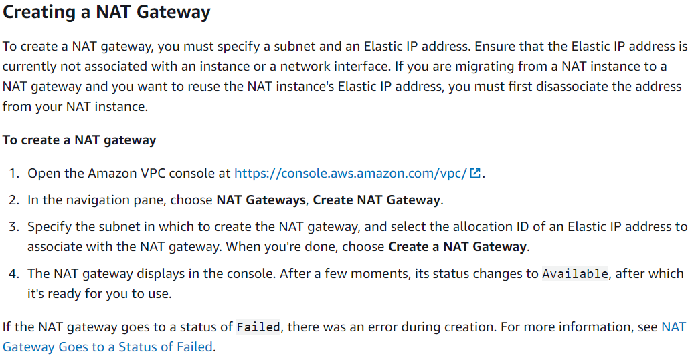

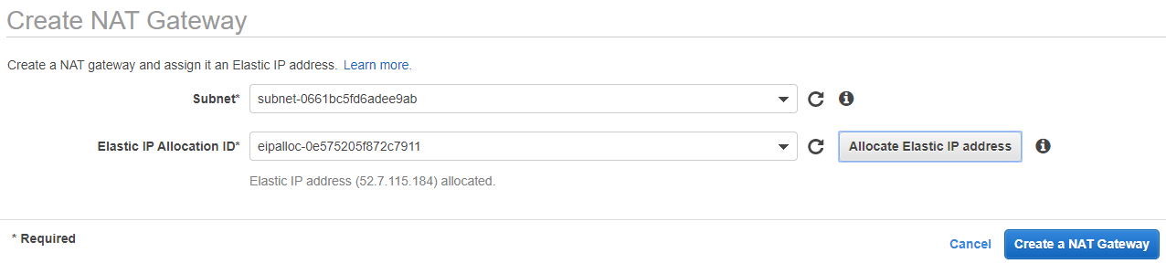

* Create it as above with elastic IP

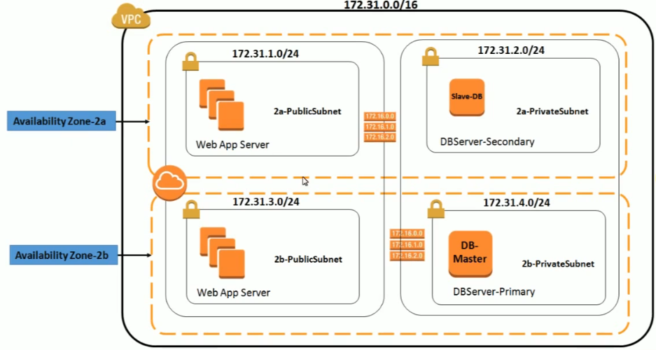

* With this, we can understand, but we need to create routing tables and assign to them so that VPC can understand

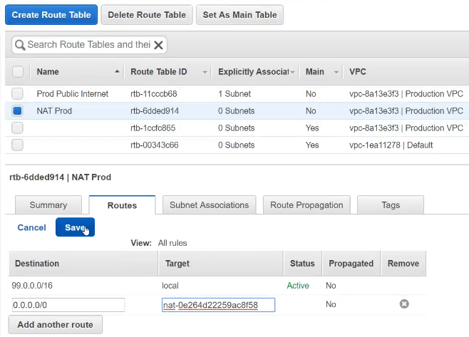

* After creating it, we need to create route table by assigning the NAT gateway. So, all the traffic will be sent to NAT
* As we see the routes IP means any instance with that IP inside VPC can communicate with each other
* 0.0.0.0/0 is to access the internet, target we need to mention the internet gateway

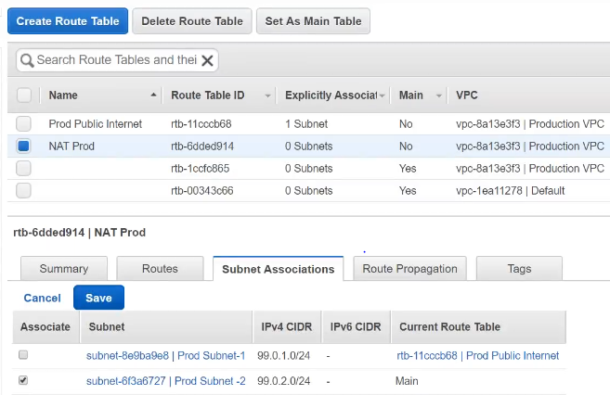

* And assign that to subnet 2 which is private subnet
* Now, we can get the internet access to the server
* NAT helps backend servers to get the internet access without exposing themselves.

**Deleting a NAT gateway:**

